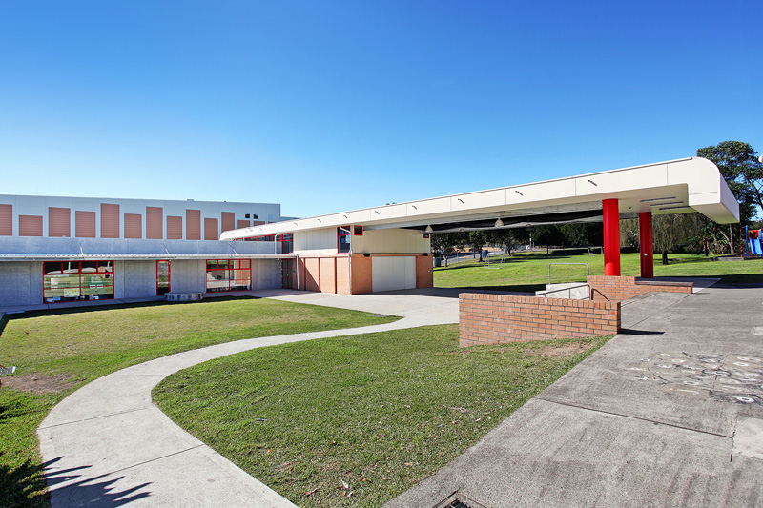1970

**St John Vianney Primary School Morisset**

Yambo Street Phone: (02) 4973 4073

PO Box 297 Fax: (02) 4973 4475

MORISSET NSW 2264

Email: [admin@morisset.catholic.edu.au](mailto:admin@morisset.catholic.edu.au)

Website: [www.morisset.catholic.edu.au](http://www.morisset.catholic.edu.au)

Yambo Street Phone: (02) 4973 4073

PO Box 297 Fax: (02) 4973 4475

MORISSET NSW 2264

Email: [admin@morisset.catholic.edu.au](mailto:admin@morisset.catholic.edu.au)

Website: [www.morisset.catholic.edu.au](http://www.morisset.catholic.edu.au)

**20th May, 2020. NEWSLETTER Term 2 ~ Week 4**

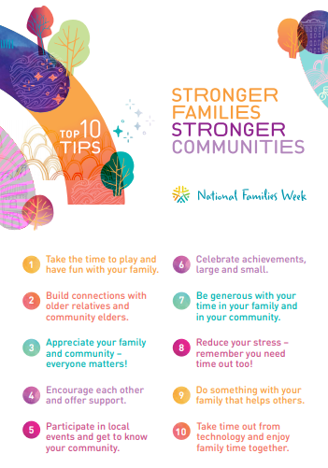

**National Families Week 15-21 May**

This week is National Families Week, where over a hundred thousand people and hundreds of organisations celebrate. It is Australia’s annual celebration of families and the aim is to celebrate the vital role that families play in Australian society. This week is a time to think about your immediate, extended family and the community around us. Take the time to reflect on the critical role that families play in teaching, supporting and nurturing children especially as they grow.

***Disclaimer:*** *Unless otherwise stated, the advertisements placed in this* newsletter *are placed by independent third parties who have no legal relationship with the Diocese.  The activities or services of the advertisers are not supervised or controlled in any way by the Diocese.  The Diocese is not in a position to endorse the advertisers or the services provided and makes no representation about those matters.  Accordingly, the Diocese cannot accept any responsibility for the advertisers or the activities or services that are the subject of these advertisements.*

The enduring theme is ‘Stronger Families, Stronger Communities’. This theme continues to highlight the important role of families. As many of us are spending more time as a family during this pandemic, we are definitely reminded of how precious families and communities are. Below are the top 10 tips to build a stronger family and community.

**Laudato Si’**



This year is the 5th Anniversary of Laudato Si, which is the Pope’s encyclical on care for our common home. It is recognised from the 16th to 24th of May. In Laudato Si’, Pope Francis teaches us that “everything is connected.” At the moment we are living through history shaping events and Laudito Si’ teaches us how to build a better world together. Pope Francis invites us to reflect, pray and join to take action during this week. We come together as one people around the world.

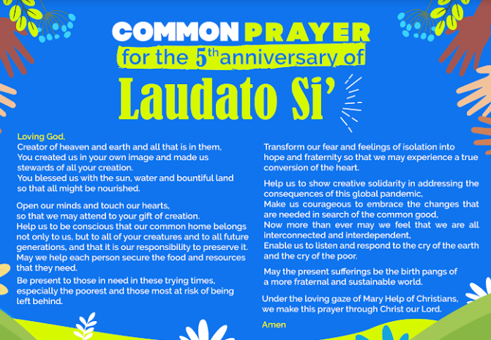

**Mary Help of Christians**

This Sunday, 24th of May, is the feast day for Our Lady Mary Help of Christians. It has been celebrated in Australia since 1844 but the history to this day, dates back to the start of the 1800's. In 1844, Mary, under the title of Our Lady Help of Christians was chosen as the patroness of Australia. Our Lady has appeared in hundreds of places throughout the world. She has brought help from Heaven through prayer and penance as a formula for peace. We celebrate this day with a very special act of thanksgiving to Our Lady by praying the holy rosary.



*Blessings to you and your families*

***Christine Hibbard (REC)***

Dear Parents

It was wonderful to see so many of our Mums and Grandmothers at our Mother’s Day celebration with a difference. It was so nice to see your families, some I have not seen for a while, with smiles on their faces and just happy to be around the school again.

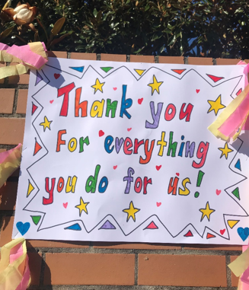I hope all the mums enjoyed their special treat and the beautiful story I shared with you. It is a story that is special to my family and something we shared with our children for many years. It was nice to be able to share it again with you and thank you for the wonderful job you have been doing over the past few months.

I hope you al enjoyed the day with your beautiful children.

Thank you to **Morisset Bakehouse** for the delicious scones and to **Chill’d Café** for the coffee.



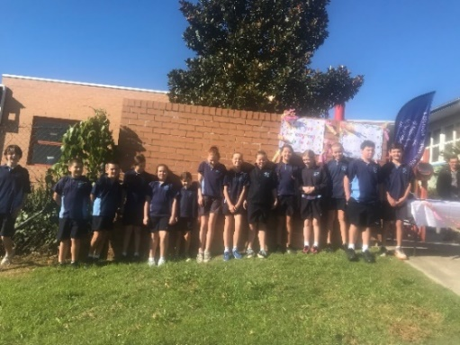

Congratulations

It was an extra special day for the Morris family. Xaria in Kinder has a new sister, Savannah. Congratulations to the family on the birth of your baby girl.

**Staff Update**

Please keep Mrs Pether in your prayers. Her mum sadly passed away in Coffs Harbour last week after a long battle with cancer. Mrs Pether should be returning next Tuesday.

Mrs Jo Williams, our Pastoral Care Worker, has had to take leave to care for her mum. Mrs Cassie Tuck has accepted the position as Pastoral Care Worker and will be working Tuesday and Thursday. Cassie also shares Yr 5 with Miss Kennedy. We look forward to working with Cassie in her new role.

**Uniforms**

All children should be in full Winter Uniform by next Monday, the 25th May. Girls should have the full uniform including navy stockings. Boys should have long sleeve shirts and long pants. Ties are to be worn. We do have some supplies in our Clothing Pool, please come into the school office if you would like to have a look.

Sports uniform should be navy track pants not stockings, with the school Jacket or Jumper.

**Weeks 5 and 6**

This morning the CSO sent a letter to all families outlining the arrangements for the next couple of weeks. Following this, I will send a note this afternoon via Compass with a school update.

**Parking**

Whilst standing at the gate each morning I have noticed a few parking issues.

* Parents parking illegally in the bus zone. You cannot stop and drop the children in the Bus Zone. This will incur a hefty fine if you are caught. The Parking Officers have already been out twice this year. If the 5 minute parking area is full, drive up the road and park.
* When stopping in the 5 min parking area, please drive forward if there is space in front of you so cars are not waiting to get in.
* Thank you to everyone who supports the parking rules and keeps everyone safe.

**Pick up and Drop Offs**

This will continue this week and possibly the next few weeks. Thank you to the parents who have supported us and are now dropping children at the gate. They can do it and have grown up so fast!

Just a few points about the pick ups

* Please come into the church grounds to pick children up. K, Yrs 3 and 4 at 2:45pm on their allotted days.
* Teachers will walk children around to meet you.
* Please do not gather and have a chat. Please leave with your children
* If you are waiting for a sibling please keep an eye on your child at all times.
* If you are running late or choose to come later when the traffic has settled, the children will be walked back to school.
* Children catching buses will wait on the blue seats and be supervised by a teacher.

If you are entering the school, please ensure the school gate is closed behind you and also closed when you leave.

**Hygiene & Cleaning Arrangements**

Listed below is a list of things, which are now in place:

* The school has employed a cleaner to come in to school twice a day to wipe down all surfaces used by the children.
* Every classroom has hand sanitizer, soap, surface spray and paper towels.
* Children are reminded to wash hands regularly or bring their own sanitizer
* Library books are being quarantined and wiped down before going out.
* Children are sanitizing before and after using the playground.
* Restricted use of class spaces.

Children and staff are often reminded of these practices and I ask you at home to do the same.

If your child is showing signs of the slightest respiratory illness (eg. runny nose, cough, temperature, itchy throat), please keep them at home. If your child arrives at school with any of these signs, you will be contacted to take them home.

**School Fees**

I understand many families are struggling financially during these difficult times. The school recognises this and would like to support you during these times. Last term a note went home from the Catholic Schools office, via Compass, asking you to complete a form if you require either a concession or a deferment of payment. Families requiring the concession will be contacted shortly to discuss this option. If you feel you are struggling with fees please consider filling in the Fee Adjustment forms.

**School Photos**

We usually have school photos in the first week of June. We have had to postpone the photos until the 4th August. You will all be receiving information closer to this time.

**Canteen**

The School Canteen will be closed until further notice.



**Education Support Staff Day**

Recently the world recognised Education Support Staff day. I would like to thank the wonderful, committed, dedicated and caring support staff at St John Vianney. Thank you for the work and support you give the teachers, children and community of SJV.

The last few months have been particularly difficult for many people but with the support of all you it has made coming to school a little easier.

If you see a member of our support team take some time this week to say thank you.

Thank you Mrs Stephens, Mrs Zammit, Mrs Pether, Mrs Rees, Mr Crowe, Mrs Mould, Mr and Mrs Nankivell, Mrs Stewart, Mrs Williams, Mrs Tuck, Miss Fiona, Sr Margaret and Mr Huens.

***icki Graham***

**2021 Kinder Enrolments**

Spaces are filling quickly and are limited for Kinder 2021. If you or you know of someone interested in attending SJV in 2021, please contact the school and collect an enrolment package.

Due to restrictions of COVID-19, interviews will be held later in the year and you will be contacted shortly about this.



**Yr 6 Fundraising**

During weeks 3 to 5, year 6 will be selling Zooper Doopers for $1 during lunch on Tuesdays and Thursdays.  Please support them to raise funds for their graduation.

**From the Assistant Principal**

“I cannot feel sufficiently grateful to our God” *Mary Mackillop (15th March, 1873)*

As we transition back to face-to-face teaching, I have learnt so much! Zoom, social distancing, self-isolation, remote learning, Seesaw and home schooling have become instant norms.

But, what I have learnt is that gratitude is the most important.

I am grateful for the opportunity to establish connections with the parents of my students, more so than ever before.

I am grateful for our amazing Learning Support Teacher and incredible Learning Support Staff who are working so hard to assist teachers in every way they can, often way beyond their required hours of employment.

I am grateful for the way in which students and staff have adapted and adjusted to this new platform of learning.

I am grateful for my ZOOM meetings where I actually get to see my class, whom I miss.

I am grateful for the overwhelming generosity of the community of SJV to reach out and care for one another in these times of crisis.

And I am grateful to a Principal who has been at school EVERY day, cleaning the school every morning before people arrive, watching the events unfold, communicating to staff and parents, making certain that all is in place for a safe environment for all who come here, listening to everyone’s concerns and responding with safe, reassuring words of wisdom.

I cannot feel sufficiently grateful. Our God is good, so is our school community by the way.



**Nicki Graham**

**Assistant Principal**

**Pastoral Care**

I would like to introduce myself - my name is Cassie Tuck and I will be the Pastoral Care Worker on Tuesdays and Thursdays for the remainder of Term 2 (you may already know me as I also teach Year 5 on Fridays). I am very excited to be appointed to this role and to work with all members of the community here at St. John Vianney. My role is to support children, parents and carers in any way, so please feel free to contact me via email or drop-in on a Tuesday or Thursday if you would like to talk. I can help families’ access different types of support, and I will also be working with the class parent network as the term progresses.

These have been challenging and uncertain times. If you or someone you know in our school community is struggling at the moment, please reach out. The school has many resources available including pantry staples, and vouchers for groceries or uniforms. You are welcome to come and help yourself to the food pantry in Mrs Graham's office at any time. If you would be more comfortable having a pantry box delivered to your home, please don't hesitate to contact me privately and this can be arranged.

My email address is:

[cassandra.tuck@mn.catholic.edu.au](mailto:cassandra.tuck@mn.catholic.edu.au)

I look forward to getting to know you and helping in any way I can.

***Cassie Tuck***

**Tennis Coaching**

Tennis coaching is conducted by qualified coach Bill Griffiths, at the Bay Hotel tennis courts, Bonnells Bay and at the Toronto Workers Club. Beginners are most welcome. Cost for the school terms is $120 and the active kids voucher is accepted. For further information and bookings please phone Bill on 0402 274 646.

**From the Learning Hub**

Please continue reading at home for the Premiers Reading Challenge - the SORA website has lots of PRC titles available.

I hope you are all enjoying the activities in your home learning. It has been lovely hearing from so many of you via email and OneNote. Years 3-6 have access to their coding tasks for this term - if you are ready to start, check your OneNote for more details.

Looking forward to seeing you soon.

Keep reading

**Kasey Gibbs**

**Teacher Librarian**

**Library Borrowing**

During weeks 3 -5, classes **Kinder – Year 2** will be borrowing as normal with Mrs Nankivell on a Monday.  Please remember to return your library books and home readers from Term 1.

**Years 3 – 6** will be at school on Wednesdays and Thursdays, so they can either borrow with their teachers on those days **OR** the children can log into **OLIVER** from home or school and reserve the items they would like to borrow.  Mrs Nankivell will check for reserved items on a Monday and will have them ready for student collection on Wednesdays – Thursdays.

**SORA** online ebooks & audio books are also available through **OLIVER OR** through the **SORA** app.

To get into **OLIVER** click on the link below:

<https://mncatholicprimary.softlinkhosting.com.au/oliver/OpacLogin?corporation=mnmorissetsjvv>

Username:      student’s first name.last name

Password:       sjv      (lowercase)

When first logging on students may have to override their usernames.  If you have any problems, please email Mrs Nankivell on [maureen.nankivell@mn.catholic.edu.au](mailto:maureen.nankivell@mn.catholic.edu.au)

***Maureen Nankivell***

***School Library Officer***

**Parish News**



**Reopening of the Church/Parish Spaces**

Following the announcement of the State Government that restrictions will be eased in three stages, people have begun to ask about when the church will be open and when we can resume small gatherings for team meetings, prayer and liturgies.

We wanted to convey to all of you that we are continuing to work with our Parish teams, Toronto Parish, our Priests, and with the Diocese about the timing and scope of any changes to our current situation. In these matters, the current consensus is that we proceed with caution and not move too quickly. We do not anticipate that we will be making any changes in the next few weeks.

We have tried to follow some simple guidelines at this time. Firstly, whatever we do, it is achievable and sustainable. Secondly, if we can’t make it available to everyone, we don’t make it available to anyone.

These haven’t been easy decisions to make, but we’ve endeavoured to be fair and consistent in applying these decisions.

The information available to us keeps changing as we navigate these waters. Rest assured we are listening to the community, to each other, and to our leaders as we discern the way forward. If anyone wishes to discuss these matters in more detail, please don’t hesitate to call the parish office.

***The Parish Leadership Team***

**Weekend Worship**

Mass will be live streamed this Sunday, at 9.30am, from Sacred Heart Cathedral. Share the link with family and friends, and let’s gather online to pray as a community in these challenging times. This will continue each week while the COVID-19 restrictions are in place.

<https://www.mn.catholic.org.au/places/live-stream/>

**Pastoral Care**

If you would like to like to speak with or see a priest please contact the parish office and leave your details for Fr Kevin to contact you.

***Don’t Miss Out On Anything In Your Diocese!***

Go to <http://mnnews.today/> to see updates and read stories about what is happening locally.

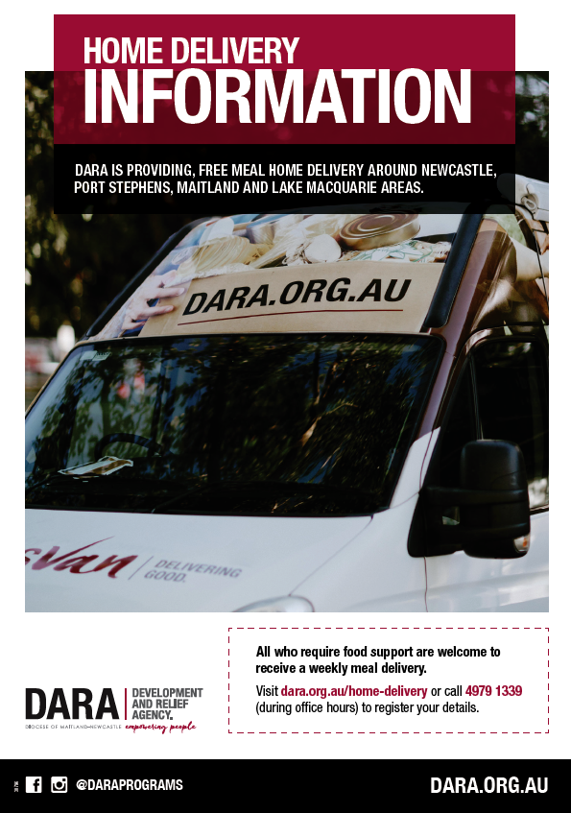



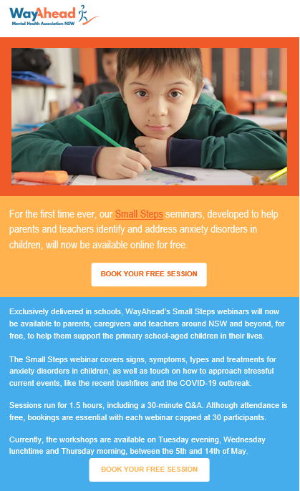

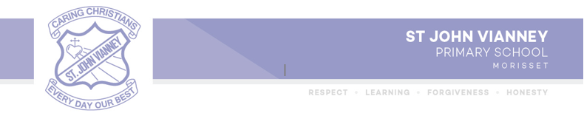

Psychology Perspective

**15 Tips for Parents when Children are Worried about Returning to St. John Vianney Morisset**

By Thibaut Huens

School Psychologist

Firstly, well done to all those parents who have been doing their best to juggle parenting, home schooling, working, working from home, caring for others and more. It’s been challenging, so well done to you. Now it’s time for kids to start returning to school and to let the professional teachers answer those millions of questions you have been fielding each day. I’m sure there have been many searches on YouTube to find out how to multiply decimals or a refresher on trigonometry?

Coming back to school after social distancing with COVID-19 can be difficult and worrying for many students (and parents). Some students may be excited to come back and see their friends/teachers and start engaging in face-to-face learning, and if this is the case that is fantastic. However, for other students there may be a certain degree of worry and fear about returning to school, especially following this time away from face-to-face teaching and in the current pandemic, this too is normal.

All of these worries can cause children to exhibit a range of behaviours that are difficult for them and us to cope as we embark on returning to school. They may become upset and tearful, may not want to leave you, become more easily frustrated with things or get angry, have meltdowns, get physical symptoms (headaches, stomach ache), have trouble falling asleep or staying asleep. These behaviours can lead to us parents becoming worried or frustrated, which in turn can further cause our child to feel anxious. We can also try and help our children by avoiding situations that we know might cause them to be worried, such as delaying our children coming back to school. However, this will only reinforce your child’s worry and anxiety in the long term.

Most students will find that these worrying feelings decrease over time once back at school and following the school routine. It will be most helpful for children and young people to return to school along with other students as outlined by their school. Of course, for those children, young people and their families who are vulnerable to COVID-19 as outlined by NSW Health, please contact your school about your circumstances and school attendance.

Below are things parents can do to help their child who may worry about returning to school.

* **Listen and help your child to identify their emotions** - It’s healthier for children to talk about their feelings—they don’t benefit from “not thinking about it.” Be empathetic, but also remind your child, *gently*, that they have done this before after long school holiday breaks.
* **Talk** about returning to school **and** **helping them prepare for the transition** – what will school look like. What is the same? What might be different?
* Develop a **calm morning routine** (organise and pack the night before) for predictability and reducing anxiety.
* Develop and **follow a quick goodbye routine.** Routines are reassuring, however, keep things quick.​ Eg. I’ll be dropping you at kiss and ride tomorrow. I will give you a big kiss and tell you I love you and then you go straight to class to drop your bag/ find your friends/teacher. I’ll be picking you up from the gate at 3.00pm and can’t wait to hear about your day.
* **On the day - leave without fanfare**. Tell your child you are leaving and that you will return, then go—don’t stall or make it a bigger deal than it is.​ Remember they are safe and cared for at school.
* Encourage them to **meet up with friends before going into school** if they can.
* **Reassure** them that **feeling anxious to new situations is normal** **and they can do things to help manage these feelings** such as mindful breathing, relaxation techniques, meditation, exercise, getting a good night sleep, positive self-talk, talking to friends.
* Helping them to **understand** that **delaying** **the return to school** is likely to **make things** **harder** in the future.
* **Build confidence** in them “I know it feels hard, but you can do it”
* Help them **develop coping statements to use at school:** “As the day goes on, I will feel less worried”, “All the teachers care about me and are there if I need them”.
* **Discuss and identify safe place​s and people** they feel comfortable to talk to at school.
* **Send notes** for your child to read at lunch​. Eg. Write a post it note in their lunch box.
* Draw a love heart on your hand and on theirs as a **reminder you are always thinking about them** – when they press the heart it’s like getting a hug from you​.
* **Give the child something of yours to hold onto while at school** (not expensive or sentimental). Maybe your favorite scarf or hat, a special photo.
* **Read a social story about returning** to school (talk to the school if this is required).
* **Reward your child’s efforts** – give them something to look forward to at the end of the day. Maybe their pick for dinner, or a special walk around the park, some afternoon game time.
* **Model for your children** how to identify and control their emotions, rather than getting worried, frustrated or angry with them.

I hope you find some of these tips helpful.

If you are concerned that your child’s worry is becoming persistent and intense, please contact the school and discuss this with your child’s class teacher. Additionally, please discuss any major concerns with your GP or mental health care provider.

Regards,

**Thibaut Huens**

Email: [Thibaut.huens@mn.catholic.edu.au](mailto:Thibaut.huens@mn.catholic.edu.au)

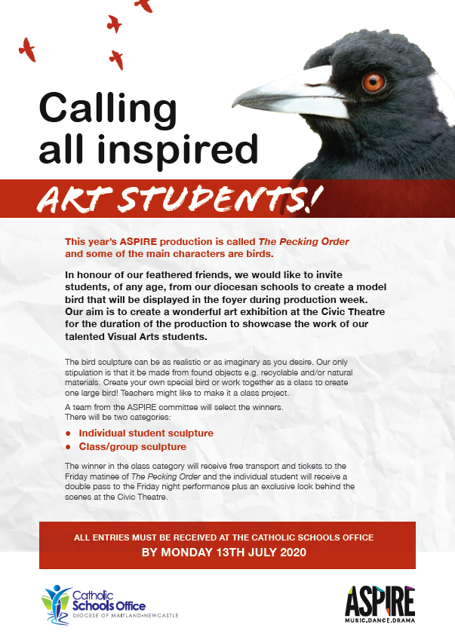

Aniela Year 1





